SECTION KA

COOLANT SPECIFICATION AND SAFETY DATA

CONTENTS

|  |  |
| --- | --- |
|  | Chapter |
| PAXCOOL Product Safety Data | 1 |
| Coolant Specification 'PAXCOOL' .. | 2 |
| Coolant Specification 'NALFLEET' | 3 |

CHAPTER 1

PAXCOOL INHIBITED ANTI-FREEZE  
MATERIAL SAFETY DATA

SUPPLIED BY

Paxman Diesels,

Paxman Works,

Colchester, Essex. COl 2HW

PRODUCT IDENTIFICATION

TRADE NAME: CHEMICAL NAME: CHEMICAL FORMULA: CAS No:

PAXCOOL Anti-freeze Proprietary mixture Proprietary mixture

SUMMARY OF HAZARDS

Slight eye irritant. May produce systemic toxic effects if swallowed.

HAZARDOUS COMPONENTS

COMPONENT NAME PERCENTAGE

TVL (units)

Ethylene glycol

approx. 90

50 vapour ceiling (ACGIH - 85/86)

Blue Liquid/Sweetish odour 1.126 <0°C >150°C

N/A

N/A

N/A

Nil

7.5 at 25%

Fully miscible

CHEMICAL AND PHYSICAL PROPERTIES

APPEARANCE/ODOUR:

SPECIFIC GRAVITY (60°F):

MELTING PT/RANGE °C:

BOILING PT/RANGE °C:

VAPOUR PRESSURE (mm Hg at 20°C):

VAPOUR DENSITY (air =1):

EVAPORATION RATE (ether =1):

PERCENT VOLATILES: pH VALUE:

SOLUBILITY IN WATER:

FIRE AND EXPLOSION HAZARDS

|  |  |
| --- | --- |
| FLASH POINT °C: | >100 (Closed Cup) |
| FLAMMABLE LIMITS: | 3.2 - 15.3% |
| EXTINGUISHING MEDIA: | Dry chemical/C02/Halon |
| HAZARDOUS DECOMPOSITION PRODUCTS: | Mainly oxides of carbon. |
| SPECIAL FIRE FIGHTING PROCEDURES: | Avoid breathing vapour. |
| UNUSUAL FIRE AND  EXPLOSION HAZARDS: | None |

REACTIVITY DATA

|  |  |
| --- | --- |
| CONDITIONS TO AVOID: | Extreme temperatures. |
| MATERIALS TO AVOID: | Oxidising agents. |
| HAZARDOUS POLYMERISATION: | Will not occur. |

HEALTH HAZARD DATA

|  |  |
| --- | --- |
| EYE CONTACT: | Slight temporary irritation |
| SKIN CONTACT: | Not significantly irritating to the skin, prolonged contact should be avoided. |
| INHALATION: | Not usually applicable. May produce irritant vapours at elevated temperatures. |
| INGESTION: | May be absorbed and cause systemic effects such as kidney damage.  Initial symptoms are vomiting, head­ache slurring of speech and incoordination. |
| CHRONIC EFFECTS OF  OVER EXPOSURE: | None known. |

EMERGENCY FIRST AID PROCEDURE

|  |  |
| --- | --- |
| EYE CONTACT: | Flush with Clean water. |
| SKIN CONTACT: | Wash with soap and water. |
| INHALATION: | Remove from exposure. Obtain medical attention. |
| INGESTION: | Obtain urgent medical attention.  DO NOT induce vomiting. Give milk or water to drink. See note for Doctors (below). |

Soak in absorbent material and collect into container, or flush away with water.

SPILLS OR LEAKS:

DISPOSAL METHODS:

STORAGE REQUIREMENT:

EXPOSURE LIMITS:

EYE PROTECTION:

SKIN PROTECTION:

RESPIRATORY PROTECTION:

VENTILATION TYPE:

Ethylene glycol - 50 ppm ceiling Chemical goggles.

Barrier cream or chemically resistant gloves.

None normally needed.

General ventilation.

EXPOSURE CONTROL INFORMATION

ENVIRONMENTAL PROTECTION

Incinerate or dispose of at appropriate waste facility in accordance with Regulations.

Closed containers away from extreme temperatures.

NOTES FOR DOCTORS

Gastric lavage should be considered if significant quantities have been swallowed in the previous 4 hours. PAXCOOL contains over 90% ethylene glycol which is metabolised to oxalic acid. This process may be delayed by the intravenous administration of ethanol which has been shown to be an effective antidote provided treatment is started within 6 hours of exposure.

MSDS PREPARED BY: PAXMAN DIESELS

REVISION DATE: 18.5.87

THIS MATERIAL SAFETY DATA SHEET CONTAINS AT LEAST THE INFORMATION REQUIRED BY THE FEDERAL OSHA HAZARD COMMUNICATION RULE, 29 CFR 1910,1200 (G) (2).

CHAPTER 2

ENGINE COOLANT 'PAXCOOL'

Inhibited Anti-freeze 'PAXCOOL'

1. The use of any type or mixture of engine coolant other than that recommended below will breach the warranty requirements of new engines as supplied by PAXMAN DIESELS LTD., unless specifically referred to PAXMAN for approval. PAXMAN recommend the use of 'PAXCOOL' inhibited anti-freeze because some proprietary anti-freeze formulations, although providing adequate protection against freezing , can actually promote corrosive attack with consequent need for costly repairs.
2. 'PAXCOOL' anti-freeze, coloured blue, is based upon ETHANEDIOL (known as 'GLYCOL' or 'ETHYLENE GLYCOL') and incorporates special corrosion inhibitors. No alcohols (such as ETHYL or METHYL) are used in the formulation, thus avoiding any possible explosive vapour hazard.
3. PROTECTION AGAINST CORROSION AND FREEZING OF THE COOLING SYSTEM MUST BE MAINTAINED AT ALL TIMES TO ENSURE LONG AND SATISFACTORY ENGINE LIFE.
4. Whilst protection against freezing may not be required, a MINIMUM concentration of 33 1/3% 'PAXCOOL' to water must be used in order to maintain full and effective corrosion protection of the complete cooling system. The recommended 'PAXCOOL' mixture will provide frost protection to -18°C. In conditions where protection is required below -18°C, the percentage of 'PAXCOOL' to water must be increased as detailed in table 'A'.

NOTE Water used for mixing with 'PAXCOOL’ should be of drinking quality and contain a maximum of 100 ppm of chlorides. If such water is not available, distilled or de-mineralised water should be used.

Initial Filling of Coolant

1. The anti-corrosion treatment applied to the cooling system prior to engine despatch should be removed before filling with 'PAXCOOL' mixture, as follows:
2. Fill the cooling system with water to which 1% by volume of ICI 'Synperonic N' low foaming detergent, or equivalent has been added.
3. Start and run the engine until the coolant has attained normal working temperature. Run for a further 10 minutes.
4. Stop the engine, allow to stand for 10 - 15 minutes, drain the coolant and allow the engine to cool to ambient temperature.
5. Thoroughly flush out the cooling system with water, drain again.
6. Fill with the appropriate 'PAXCOOL' mixture.

Topping Up Coolant

1. When topping up to compensate for coolant losses the correct 'PAXCOOL' water mixture

must be used. If coolant loss is due to evaporation, water may be used provided that this is added

during engine operation and becomes thoroughly mixed with existing coolant in the system.

Contamination of Coolant

1. If any exhaust gas contamination of the coolant should occur, it is possible to lose the protection against corrosion. To prevent this situation arising, it is recommended that the condition of the coolant is monitored regularly (eg. monthly) using either a pH meter or test papers/strips which can clearly indicate pH readings. A reading of pH7 IS THE LOWEST PERMISSIBLE VALUE. If a reading of less than pH7 is taken, the coolant must be drained, the cause of contamination rectified and the engine cooling system refilled with fresh 'PAXCOOL/water mixture. Suitable pH indicator test paper/strips can be obtained from PAXMAN DIESELS LTD.

NOTE Coolant samples should NOT be taken from expansion or header tanks, where evaporation may result in incorrect test results.

Duration of Protection

1. It is recommended that engine cooling systems protected by 'PAXCOOL' anti-freeze are drained and refilled with a fresh 'PAXCOOL’/water mixture of the correct concentration at INTERVALS OF TWO YEARS.
2. Where the engine installation is used essentially for standby power duties, the interval between changes can be extended to THREE YEARS.
3. The degree of frost protection given by 'PAXCOOL'/ water mixtures is shown in table 'A'. Checks for the concentration of coolant mixtures can be carried out by means of a hydrometer, using the data shown in table 'B'.
4. 'PAXCOOL' is not compatible with other anti-freeze formulations and should never be mixed with them.
5. In common with all anti-freeze formulations, 'PAXCOOL' is harmful if swallowed. Safety precautions shown on drums containing 'PAXCOOL' should be observed. Also refer to 'PRODUCT SAFETY DATA' (Chapter 1), supplied with each delivery.

TABLE A

|  |  |
| --- | --- |
| Minimum Temperature | Paxcool Concentration |
| degrees Celsius |  |
| -18 | 33.33% (1 Part Paxcool to 2 Parts water) |
| -25 | 50% (1 Part Paxcool to 1 Part water) |

TABLE B

TEST

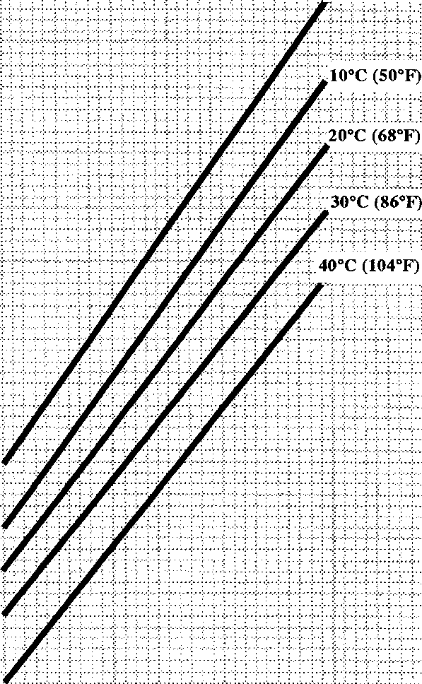TEMPERATURE  
0°C (32°F)

QO

r-

><

H

HH

o

u

**so**

u

w

CL

***m***

Tf

o

20 30 40 50

PERCENTAGE OF PAXCOOL TO WATER

SPD 00366

CHAPTER 3

ENGINE COOLANT 'NALFLEET'

1. Where the environmental conditions of the vessel is tropical the use of an anti­freeze can be replaced by using an inhibited coolant treatment.
2. The only treatment recommended by Paxman Diesels Limited where 'PAXCOOL' is considered unnecessary is 'NALFLEET 9-111’ which is readily available worldwide.'

•NALFLEET 9-111'

DIESEL COOLING WATER CORROSION INHIBITOR

Product Description

'NALFLEET 9-111' contains a balanced mixture of corrosion inhibitors in liquid form, together with an anti-incrustant.

Colour dark blue

Weight 1.36 kg/litre

pH 12.3

Protects all metals (including aluminium) in engine cooling systems from corrosive attack

Keeps systems free from sludge and scale deposits

Does not affect gaskets or hoses

Supplied in liquid form

Contains specific copper corrosion inhibitor

Compatible with anti-freeze solutions.

Approved by major diesel engine manufacturers UK Department of Trade approved

Product Uses

'NALFLEET 9-111' is particularly effective in preventing corrosion in engine cooling systems. 'NALFLEET 9-111’ will protect ferrous metals, copper and copper alloys, lead solder and aluminium. It will not affect rubber gaskets or hose.

'NALFLEET 9-111' is effective in hot and in cold fresh water, and is fully compatible with glycol/water mixtures. 'NALFLEET 9-1 IT also contains an anti- incrustant to prevent deposition on hot surfaces and keep waterways in radiators clear.

'NALFLEET 9-1 IT has been approved by the Department of Trade and Industry for use in an engine cooling system circulating as the heating medium for generators producing fresh water for drinking and culinary purposes, provided the recommended dosage rates are adhered to.

Application, Dosage and Control

'NALFLEET 9-111' may be drawn direct from the drum but because of the alkalinity of the neat product plastic taps should be used for dispensing.

The concentration of 'NALFLEET 9-111' in the cooling water should be in the proportion (by volume) of 1 part 'NALFLEET 9-111' in 125 parts cooling water (8 litres per tonne). It must not exceed 1 part in 80 (121/2 litres per ton).

'NALFLEET 9-111' should be introduced after circulation of the cooling water has begun. 'NALFLEET 9-111' is best added by means of a feeder installed on a by-pass to the circulating system, or connected via a throttle valve to the circulating pump discharge and delivering to the header tank. For. small systems 'NALFLEET 9-111’ can be added slowly to the header tank.

Empty and flush the cooling system thoroughly before commencing treatment, to remove as much old rust as possible. If the system is exceptionally rusty it is advisable to repeat this procedure after the first week or two of treatment.

Control is by a simple test for nitrite and pH. Your Nalfleet Representative will provide details of the test method and test kit which are available.

Cleaning Procedure

The cleaning process should be carried out in two stages, firstly an oil and grease removal, followed by a second inhibited acid clean to remove calcium scale deposits or corrosion products.

1. Removal of Oil and Grease

Drain engine cooling system and flush thoroughly with fresh water - generally 20 to 30 minutes.

Fill system with 2 - 5% solution of 'NALFLEET 9-010' and recirculate for 2 to 4 hours at 60 to 80°C.

Drain and flush thoroughly with fresh water.

1. Removal of Calcium Scales

Fill system with a 5% solution of 'NALFLEET 9-068' and recirculate for 4 to 8 hours at 60 to 75°C.

Drain and flush thoroughly with fresh water to remove all loosened deposits.

To ensure complete removal of acid, thorough flushing with fresh water is necessary until the pH of the rinse water is above 6. A final rinse with distilled water is recommended.

1. Removal of Corrosion Products

For details of this process consult your Nalfleet Technical Representative.

When the cleaning procedures are complete, refill, recirculate and then add the initial dosage of 'NALFLEET 9-111' and return unit to service.

Packaging, Handling, First Aid and Storage

'NALFLEET 9-111' is supplied in drums containing 25 kg.

CAUTION AS THE NEAT PRODUCT HAS A HIGH ALKALINITY CONTACT WITH NON-FERROUS METALS SHOULD BE AVOIDED AS UNDESIRABLE REACTIONS MAY OCCUR.

'NALFLEET 9-111' IS ALKALINE. CONTACT MAY CAUSE EYE INJURY AND SKIN IRRITATION. AVOID CONTACT WITH EYES, SKIN AND CLOTHING. DO NOT TAKE INTERNALLY. GOGGLES AND RUBBER OR PVC GLOVES SHOULD BE WORN. IF SPLASHING OCCURS, REMOVE CLOTHING AND WASH BEFORE RE-USE. WASH AFFECTED SKIN LIBERALLY. FLUSH EYES WITH COPIOUS AMOUNTS OF CLEAN WATER AND OBTAIN MEDICAL ATTENTION. IF SWALLOWED, GIVE LEMON JUICE OR DILUTE VINEGAR IMMEDIATELY TO NEUTRALISE ALKALI. OBTAIN MEDICAL ATTENTION IMMEDIATELY.

DO NOT GIVE AN UNCONSCIOUS PERSON ANYTHING TO DRINK.

NALFLEET  
MARINE CHEMICALS  
P.o Box No. 11,

Northwich,

Cheshire  
CW8 4DX,

U.K.

Tel: Northwich (0606) 74488 Telex: 66-8663

Nalfleet Ref: LP2/03/0187

**SECTION KA**

**COOLING SYSTEMS**

CONTENTS

|  |  |
| --- | --- |
|  | chapter |
| Fresh Water Cooling Circuit- | 1 |
| Sea Water Circuit | 2 |
| System Draining | 3 |

3 4^6 7 89 10

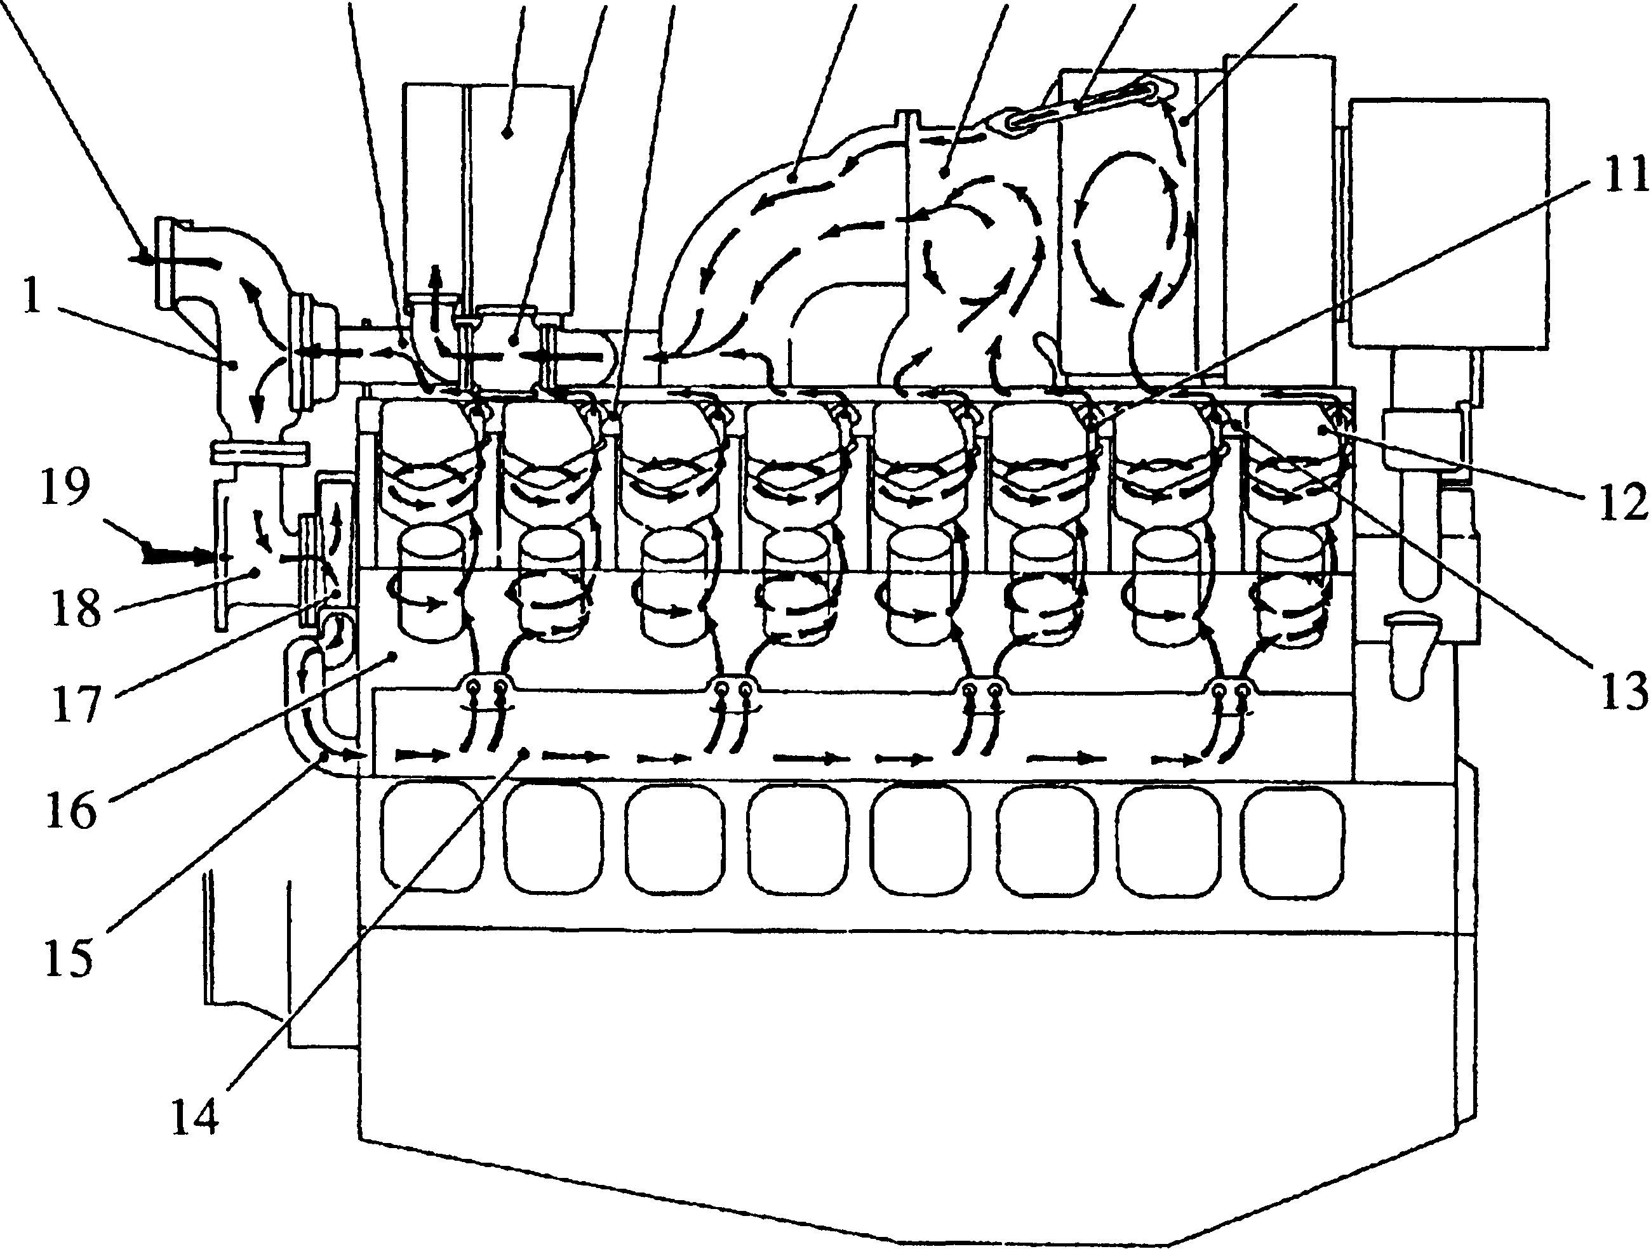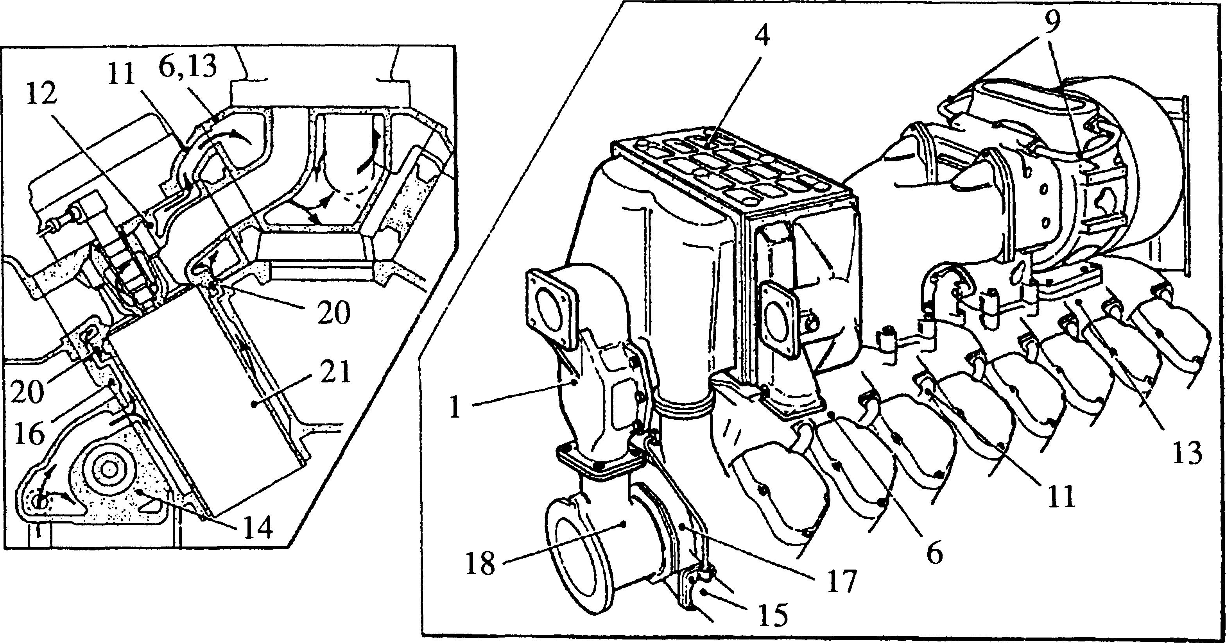

Key To Numbers

SPD00359

|  |  |  |  |
| --- | --- | --- | --- |
| 1. | Coolant thermostat | 12. | Cylinder head |
| 2. | Coolant outlet to heat exchanger | 13. | Exhaust manifold, drive-end |
| 3. | Coolant piping to thermostat | 14. | Fuel pump cambox |
| 4. | Charge air heater/cooler | 15. | Coolant delivery pipe |
| 5. | Diverter valve | 16. | Crankcase |
| 6. | Exhaust manifold, free-end | 17. | Coolant pump |
| 7. | Exhaust outlet bend | 18. | Suction branch |
| 8. | Turbine inlet casing | 19. | Coolant return from heat exchanger |
| 9. | Water transfer pipes | 20. | Transfer ferrules |
| 10.  11. | Turbocharger  Outlet bend, cylinder head to exhaust manifold | 21. | Cylinder liner |

Fig KA.l Engine coolant circulation

CHAPTER 1

ENGINE COOLING CIRCUIT

1. The engine driven coolant pump (17)(Fig KA.l) circulates coolant in a closed circuit through the engine, turbocharger, heater section of the charge air heater cooler and heat exchanger.
2. The system is filled from the make-up tank connected to the coolant pump inlet, vent pipes in the system ensuring that all air in the system is expelled back to the tank. A pressurising valve is fitted to the top of the tank. This valve is of the double acting type, venting excess pressure when the engine is running, and opening in the reverse direction when the engine is at rest to prevent a vacuum forming in the system.
3. When the engine commences to operate, coolant pump (17) delivers coolant to the inlet manifolds incorporated in fuel pump camboxes (14) on either side of crankcase (16) where it enters the cylinder jackets. After circulating around cylinder liners (21), the coolant passes to cylinder heads (12) via transfer ferrules
4. fitted between the crankcase and heads. Within the heads the coolant circulates round the injector housings and valve seats before flowing out to exhaust manifolds
5. and (13) via outlet bends (11).
6. From the exhaust manifolds, coolant is supplied to turbocharger (10), turbine inlet casing (8) and exhaust bend (7). After circulating through the turbocharger, coolant is returned to the turbine inlet casing via pipes (9), mixing with the coolant in the upper portion of the turbine inlet casing before flowing to the exhaust bend where it mixes with the coolant in the bend. On leaving the exhaust bend, the coolant joins with that flowing from the free-end exhaust manifold, before passing to coolant thermostat (1) via the diverter valve and charge air heater/cooler bracket.
7. When the coolant temperature is below 40°C, some of the coolant is diverted by valve (5) through the heating section of the charge air heater/cooler before entering the charge air heater/cooler bracket. When the air inlet temperature rises above 40°C the diverter valve will pass the coolant directly to the charge air heater/cooler bracket.
8. The heater section of the charge air heater/cooler is included in the circuit to provide a means of heating the cooled air, ensuring that the air temperature is not too low for efficient combustion.
9. The thermostat is incorporated in the system to enable the coolant to reach its optimum operating temperature rapidly (see Section KG). As the coolant temperature is lower than the minimum setting of the thermostat when the engine first commences to operate, thermostat outlet (2) to the heat exchanger is closed and all coolant flows from the thermostat to pump suction branch (18) via a by-pass pipe. As the temperature of the coolant rises above the minimum setting of the thermostat, the thermal elements in the thermostat start to open to permit a certain amount of coolant to flow to the heat exchanger. When the coolant attains its operating temperature (see Section CB), the flow through the by-pass pipe almost ceases, the majority of the coolant passing to the heat exchanger for cooling.

A pre-warming unit, mounted near the engine, is incorporated in the system. When the engine is at rest, thermostatically controlled heaters in the unit warm the coolant and a motor driven pump circulates it through the engine. This reduces 'warm up' time and enables the engine to run on load immediately after starting. The setting of the heaters is below that of the engine thermostat preventing any flow through the heat exchanger. Two isolating valves are incorporated in the circuit and these must be left 'open' at all times after the cooling system has been filled unless it is necessary to remove the pre-warming unit for maintenance purposes.

CHAPTER 2

SEA WATER CIRCUIT

1. The sea water system is an open circuit, the sea water being circulated by a centrifugal self-priming pump (2)(Fig KA.2)(see Section KC) driven from the free- end of the crankshaft by 'Vee' belts.
2. The pump supplies sea water to the charge air section of charge air heater/cooler
3. , lubricating oil cooler (1) and heat exchanger (6) in that order. A secondary flow from the pump, via an orifice plate (3) supplies sea water to gearbox oil cooler (4).
4. Regulating valves (5) in the overboard discharge are set and locked to maintain a satisfactory head at the pump under all conditions.
5. Overboard discharge is via the underwater exhaust valve.
6. It is essential that the suction filters fitted to the sea water circuit are inspected and cleaned at regular intervals. Only operating experience can determine the actual frequency of inspection but for initial operation it is suggested that the filters are inspected weekly.
7. Partially blocked suction filters will result in low flow rates indicated by increased operating temperatures. The low flow rate can also lead to tube corrosion.
8. Alternatively, partially blocked suction filters may result in particles being forced through the mesh with the possibility of partial or total blockage of the tubes in the charge air heater/cooler, oil cooler, heat exchanger and gearbox oil cooler. This will again result in increased operating temperatures but with the added danger of tube erosion caused by high flow rates in unblocked tubes and tube corrosion caused by low flow rates or stagnant conditions in blocked tubes.

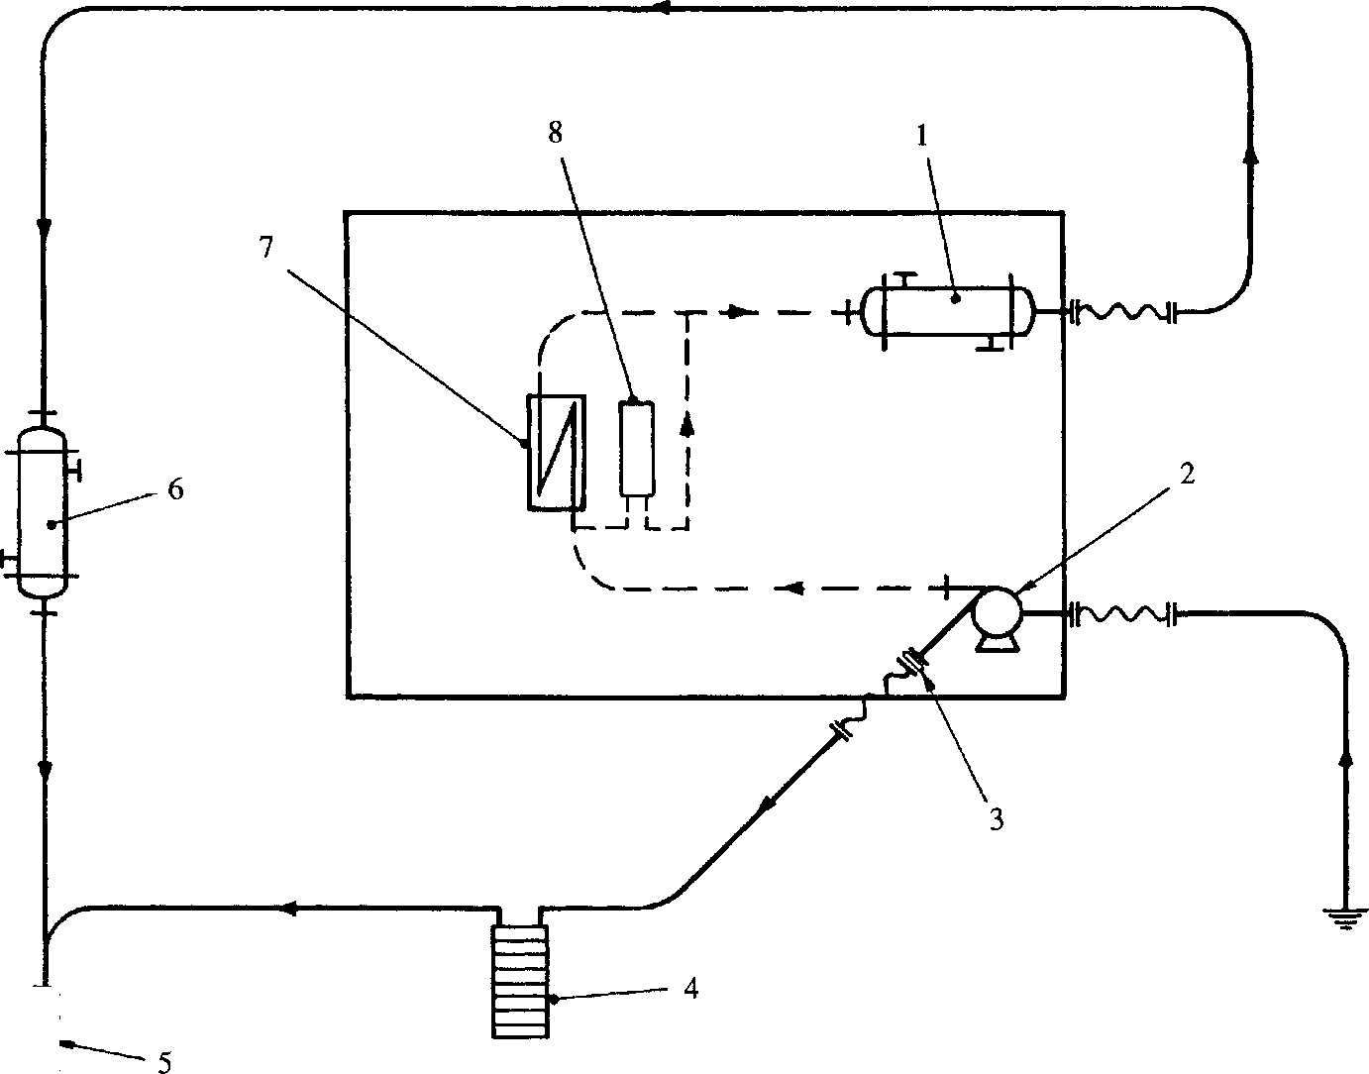

**-IHXHf**

<r

**SPD00502**

Key To Numbers

1. Lubricating oil cooler
2. Sea water pump
3. Orifice plate
4. Gearbox oil cooler
5. Regulating valve
6. Heat exchanger
7. Charge air heater/cooler
8. Fuel oil cooler

Fig KA.2 Schematic arrangement of sea water system

CHAPTER 3

SYSTEM DRAINING

Coolant Circuit

1. No facility is provided for collecting drained coolant or for leading it away from the engine. If it is required to collect the majority of the coolant, the flexible supply pipe from the pre-heat unit should be disconnected at the engine solid piping and the coolant drained into a suitable container. This action will drain most of the coolant from the engine leaving a small amount to be drained by means of the crankcase, coolant manifold and exhaust manifold drain plugs.
2. Close the isolating valve from the coolant make-up tank to the engine. DO NOT CLOSE THE ISOLATING VALVES IN THE VENT RETURNS TO THE TANK.
3. Remove the starter motors as these are immediately beneath the drive-end crankcase drain plugs.
4. Remove the free-end and drive-end crankcase drain plugs (3) and (6)(Fig KA.3) on both engine banks.
5. Remove the free-end and drive-end coolant manifold drain plugs (4) and (5) on both engine banks. The manifolds are incorporated in the fuel pump camboxes.
6. Remove plug (2) in the drive-end exhaust manifold.
7. Replace the plugs immediately draining is complete.
8. Remove the coolant drain plugs from the heat exchanger to allow the coolant to drain from the heat exchanger and the piping between the engine and heat exchanger.

Sea Water Circuit

1. With a few exceptions the sea water circuit will drain automatically immediately the pump stops working. To ensure that the circuit is fully drained proceed as follows:
2. Remove the drain plug in the sea water pump casing. This will drain the trapped sea water in the pump and in the pipe to the charge air heater/cooler. Replace the drain plug.
3. Remove the drain plugs in the charge air heater/cooler headers. Replace the plugs after draining is complete.
4. Remove the drain plugs in both the engine heat exchanger and the gearbox oil cooler and check that all water is drained. Replace the plugs.
5. Check that any 'low' sections of the sea water piping are also drained.

Key To Numbers

1. Fuel pump cam box/coolant manifold
2. Drain plug, exhaust manifold drive-end
3. Drain plug, crankcase free-end
4. Drain plug, cambox/coolant manifold free-end
5. Drain plug, cambox/coolant manifold drive-end
6. Drain plug, crankcase drive-end

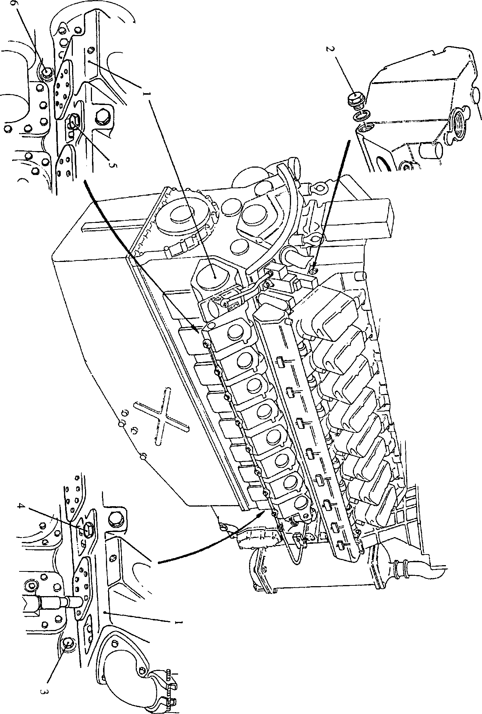

**SPD00503**

**Fig KA3 Engine coolant drain points**

SECTION KA

ENGINE PRE-WARMING UNIT

THIS EQUIPMENT IS OF PROPRIETARY MANUFACTURE.  
MAKER'S OPERATING AND MAINTENANCE INSTRUCTIONS  
ARE CONTAINED OVERLEAF

INSTRUCTION MANUAL

FOR

OPERATION AND MAINTENANCE

OF

ENGINE PRE-WARMING UNIT

Publication No. 3311

FOREWORD

These instructions have been compiled to assist personnel responsible for the operation and maintenance of equipment supplied by Regulateurs Europa Limited.

Whilst every care has been taken to ensure that the equipment has been accurately represented, it should be appreciated that with the continuing progress of design and the diversity of application, certain items may differ in detail. In addition, whilst reserving the right to make ANY alteration in design which they may consider necessary the manufacturers absolve themselves from making any such alteration retrospective.

In addition to the information given herein, practical advice and assistance is available from our 'After Sales Department' at Colchester.

SAFETY

Equipment supplied or manufactured by Regulateurs Europa may contain one or more of the following:

1. Rotating parts
2. High pressure oil
3. Compressed air
4. High voltages
5. Pre-loaded springs

All of the above items represent a potential danger or hazard to operating personnel, therefore the operator should be aware of the working principles and safety procedures involved with the equipment being used. Before working on the equipment, the following points should be observed:

1. Consult the Instruction Manual
2. Ensure that the overall operator-in-charge is informed of the nature of work being carried out.
3. Display and secure warning notices at both local and remote control positions
4. Isolate all electrical and pneumatic supplies at their source
5. Ensure that the equipment cannot be activated in any way from a remote position. (In the case of key operated equipment, all keys must be in the operators possession).

Finally, before the equipment is released for operation, ensure that relevant supplies are reconnected, safety guards replaced and all tools removed.

SAFETY OF PERSONNEL OPERATING AND MAINTAINING  
EQUIPMENT MANUFACTURED BY REGULATEURS EUROPA

LIMITED

Before carrying out any repairs, adjustments or maintenance to any equipment by Regulateurs

Europa Limited, it is essential that the following safety precautions are observed:

1. General

The equipment may contain one or more of the following:

1. High voltages
2. Rotating parts
3. High pressure oil
4. Compressed air
5. Pre-loaded springs

All of the above items represent a potential danger or hazard to operating personnel and the operator should take care to make himself thoroughly familiar with the operating principles, methods of adjustment and the dismantling and assembly procedures (where applicable) concerning the equipment in his care.

1. Before carrying out any repairs, adjustments or maintenance to the equipment or unit, the operator should ensure that any such unit or equipment cannot be activated from a remote position. To achieve this condition, he should ensure that all electrical/pneumatic supplies to the prime mover starter system are isolated at their incoming source and that all electrical supplies to control systems are isolated by the withdrawal of the relevant fuses or by disconnecting the incoming electrical supply at the control board. In addition to these precautions, visual warning notices should be prominently displayed by the equipment or unit and also at any remote control positions. Where control cabinets and consoles are secured with keys, all such keys should be in the possession of the operator carrying out the work. Information regarding position, level and type of work to be carried out should also be made available to the 'Engineer in Charge' of the installation to prevent attempted use of the equipment or unit during breakdown.
2. In the case of electrical/electronic control systems, the operator should make careful reference to the Instruction Manual to ensure that he is aware of any special safety precautions which are peculiar to that particular equipment or unit.
3. Before the equipment or unit is finally released for operation, operating personnel should ensure that all tools and repair equipment have been removed and that all safety guards are securely replaced (where applicable). All fuses should be replaced and operating mediums (electrical and pneumatic supplies) should be opened or reconnected.

ELECTROSTATIC PRECAUTIONS

|  |  |
| --- | --- |
| WARNING | THIS EQUIPMENT CONTAINS COMPONENTS THAT ARE ELECTROSTATIC SENSITIVE. ELECTROSTATIC DAMAGE CAN CAUSE IMMEDIATE FAILURE OR SHORTENING OF USEFUL LIFE. |
|  | SERVICING PCB'S AT COMPONENT LEVEL SHOULD BE DONE AT AN ELECTROSTATIC FREE WORK STATION. IF SITE WORK CANNOT BE AVOIDED THE FOLLOWING PRECAUTIONS MUST BE TAKEN: |
| A) | ALL TOOL TIPS MUST BE EARTHED |
| B) | PERSONAL WRIST OR ANKLE EARTH STRAPS MUST BE WORN. TO PROTECT AGAINST PERSONAL HAZARD THE RESISTANCE OF THE EARTH STRAP SHOULD BE APPROXIMATELY 250K OHMS |
| C) | PCB’S OR COMPONENTS SHOULD BE TRANSPORTED IN STATIC FREE PACKAGING AND WHEN REMOVED FROM PACKAGING LAID ON A STATIC FREE SURFACE AFTER OR PRIOR TO ASSEMBLY. |

Electrical Interference

To avoid possible malfunction of the equipment or infringement of Electrical Interference Regulations, the following precautions must be taken:

1. All cable screens to be terminated and earthed at the entry to the equipment
2. The equipment to have a low impedance earth
3. All doors and covers etc to be firmly secured.

SERVICE FACILITIES

To ensure prompt and satisfactory attention to customer’s enquiries, all communications should refer to the UNIT TYPE and SERIAL NUMBER, as stamped on the nameplate.

In order to obtain the most efficient service it is recommended that all enquiries for service or spare parts to be addressed to the manufacturer of the equipment to which the unit is fitted.

Customer training can be provided either in Colchester or Roden or on site. Contact below for further details.

REGULATEURS EUROPA LIMITED  
St. Leonards Works

COLCHESTER ESSEX COl 2NX ENGLAND  
Telephone 0206 799556 - 8 Telex 98438 RELD.G.  
Fax: 0206 792685  
Telegrams Governors Colchester

REGULATEURS EUROPA B.V.  
Energieweg 8  
RODEN NETHERLANDS  
Telephone Roden 0590819888 Telex 53672  
Fax: 010 3113618  
Telegrams Regulateurs Roden

|  |  |
| --- | --- |
|  | INDEX |
| Chapter 1 | GENERAL DESCRIPTION |
| Chapter 2 | OPERATION |
| Chapter 3 | MAINTENANCE |
| Chapter 4 | DRAWINGS |

CHAPTER 1

GENERAL DESCRIPTION

The unit is for use with fast patrol boat engines to maintain the Engine Fresh Water system at 65°C prior to starting, in order to facilitate starting and to eliminate white smoke caused by partially burnt fuel.

The equipment comprises a horizontal tubular heat exchanger containing three (3) electric elements rated at 6kW each, an electric circulating pump and associated control equipment.

CHAPTER 2

OPERATION

The 3 phase supply enters the control gear box and is fed to the input of the transformer, pump starter and the 6 and 12kW contactors.

If the water temperature within the heat exchanger is below the setting on the thermostat the contacts will be closed, and if the control switch is not in the 'OFF' position the control voltage will be fed to the pump starter coil. When the auxiliary contact of this is closed the control voltage will pass to the coil(s) of the heater contactor(s) depending on the heating level selected. These contactors will close and energise the respective elements.

Three 24V lamps show the status of the control voltage and the 6 and 12kW contactors.

When the water temperature reaches the set point of the thermostat then all control voltage is removed from the pump starter and element contactors. When the contacts in the thermostat re­close, the pump and selected heaters will be energised again.

CHAPTER 3

MAINTENANCE

The pump unit may be serviced and for relevant details refer to Smedegard Drawing SA782.

The contactors, pump starter, overload unit and transformer within the control equipment should be replaced if faulty as should also the immersion heater elements and single thermostat.

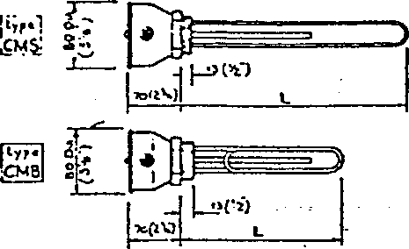

**Water Immersion Heaters**

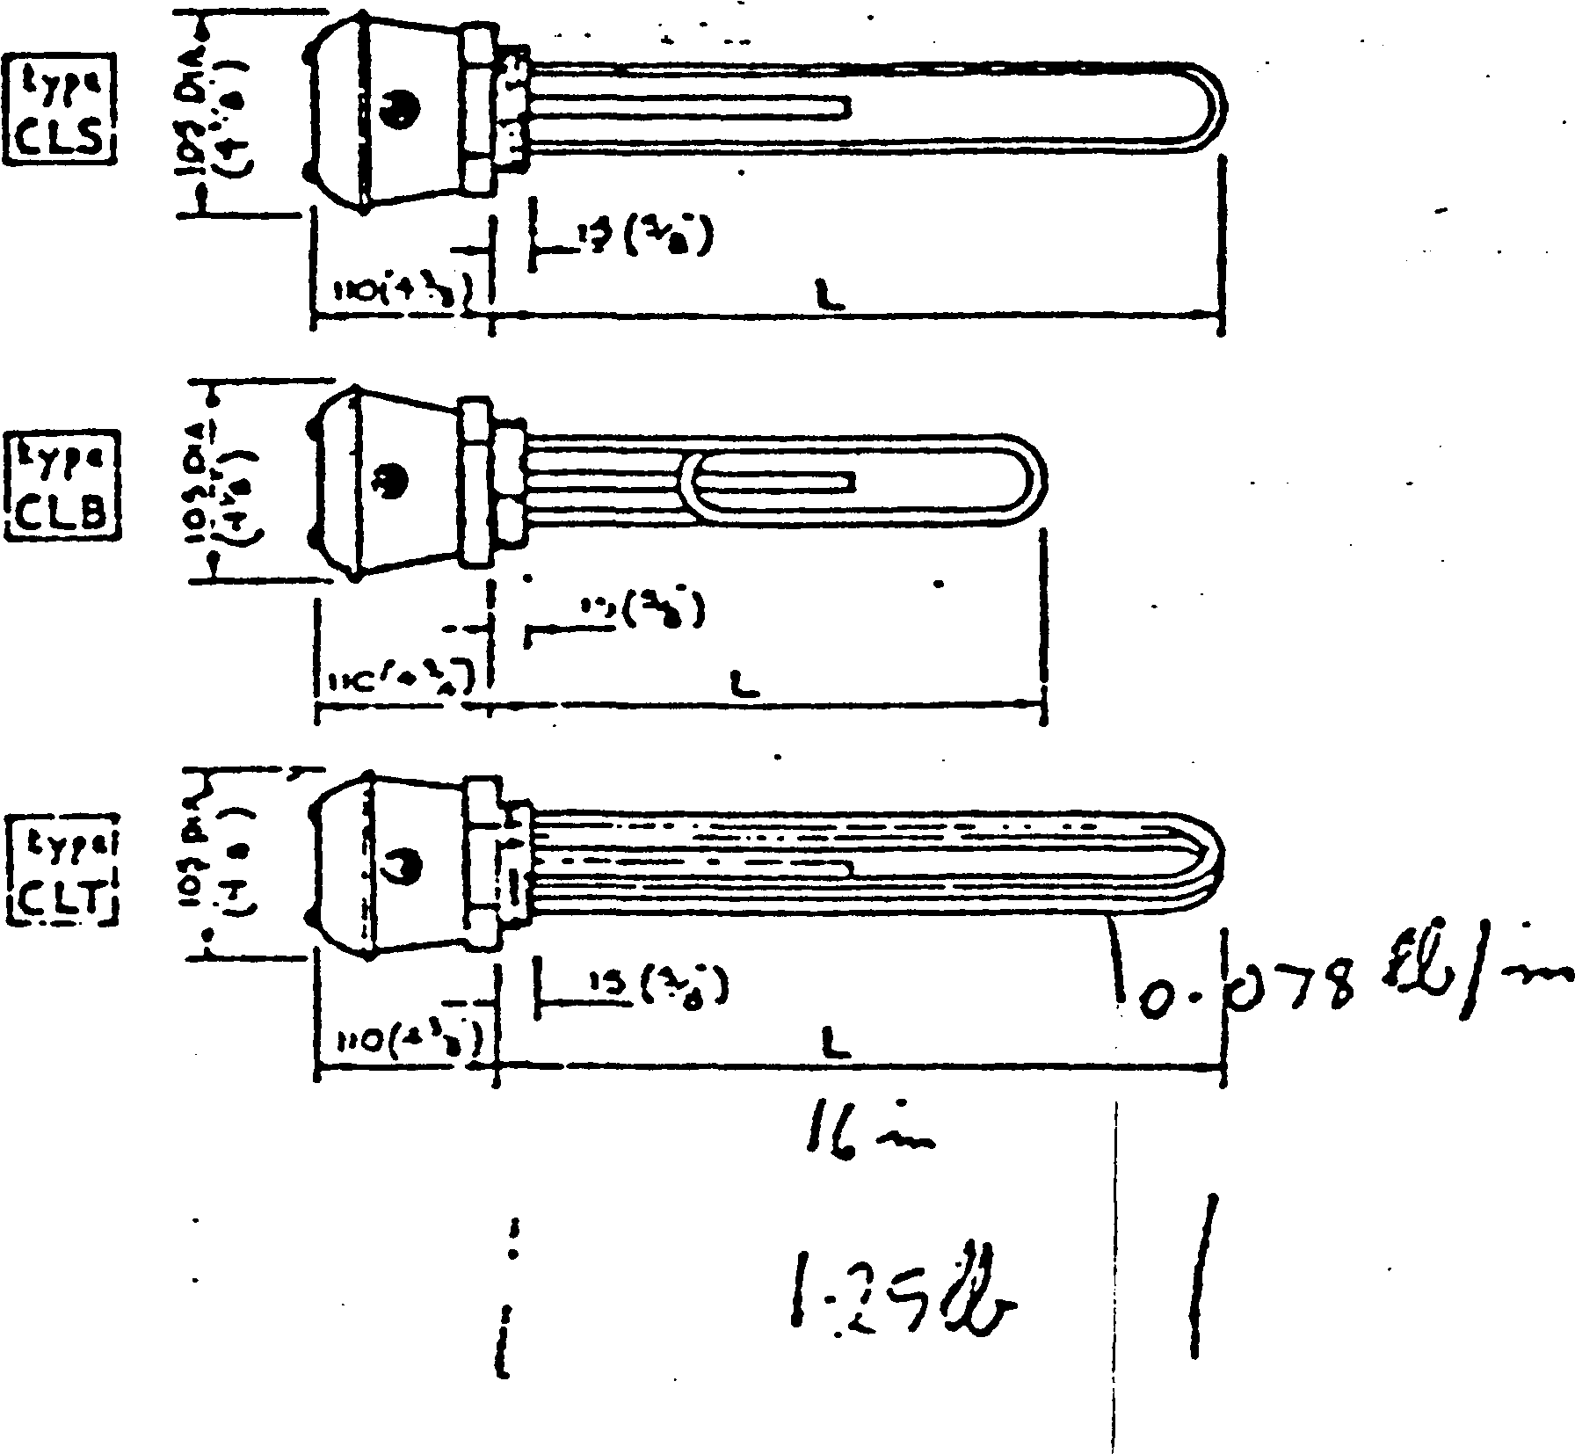

purpose: Typical applications include installation of heaters in humidifiers, domestic and industrial storage cylinders and tanks,

C for frost protection in cooling towers, defrosting in refrigera- plant, sterilisers, laboratory equipment, vending machines, etc. description: Sheathed type immersion heaters for water consist of solid drawn copper sheathed elements mounted on standard in. or 2y in. B.S.P. screwed headshaving 15*00 mm., (} in.) length of thread. Heaters can, however, be supplied with special heads if required. Heaters are fitted with metal terminal covers having conduit entry, but heavy weatherproof covers can be supplied, notes: Adjustable thermostats can be incorporated in the head of the heater. A safety cut-out may also be fitted together with the thermostat if required. These are recommended if heaters are fitted in humidifier units where continuous boiling Is necessary and water starvation can occur. For normal operation these heaters may be horizontally or vertically mounted.

If the heaters are to be used in a caustic or alkaline solution, mild steel or stainless steel elements are supplied. For special applica­tions elements are down-rated* to give a low surface temperature; also long cold terminal ends may be fitted if necessary, orders/enquiries: Please state if any of the following are required: Weatherproof terminal cover/Back nut/Thermostat, and if so, the working temperature/Safety Cut-out If not for water state tvpe of solution to be heated.

Type CMS: single loop, 1 phase 11 and 11 In. B.S.P. screwed head

Type Watts Length V

mm kru

|  |  |  |  |
| --- | --- | --- | --- |
| CMS 5 | 500 | 255 | 10 |
| CMS 7 | 750 | . 255 | 10 |
| CMS io | 1000 | 280 | 11 |
| £MS 15 | 1500 | 405 | 16 |
| £MS20 | 2000 | 535 | 2t |
| ‘CMS 25 | 2500 | 635 | 25 |
| CMS 30 | 3000 | 760 | 30 |
| CMS 40 | 4000 | 1020 | 4Q |
| CMS 50 | 5000 | 1270 | 50 |
| CMS 60 | 6000 | 1520 | •o' |
| Type CMB: | bent loop, 1 phase | |  |
| U nnd 1) in. B.S.P. screwed head | |  |  |
| CMB 5 | 500 | 150 | 6 |
| CMB 7 | 750 | 150 | 6 |
| CM3 10 | 1000 | 180 | 7 |
| CMB IS | 1500 | 255 | 10 |
| CMB 20 | 2000 | 305 | 12 |
| CMB 25 | 2500 | 355 | 14 |
| CMB 30 | 3000 | 430 | 17 |
| CMB 40 | 4000 | 560 | 22 |
| CMB 50 | 5000 | 685 | 27 |
| CMB 60 | 6000 | 610 | 32 |
| Type CLS: single loop, 1 phase | | |  |
| 2 and 21 In. B.S.P. screwed head | |  |  |
| CLS 10 | 1000 | 305 | 12 |
| CCS 15 | 1500 | 305 | 12 |
| CLS 20 | 2000 | 405 | 10 |
| CLS 25 | 2500 | 480 | 19 |
| CLS 30 | 3000 | 585 | 23 |
| CLS40 | 4000 | 760 | 30 |
| CLS 50 | 5000 | 940 | 37 |
| CLS 60 | 6000 | 1140 | 43 |
| Type CLB: bent loop, 1 phase | | |  |
| 2 and 21 In. B.S.P. screwed head | |  |  |
| CLB 10 | 1000 | 205 | 8 . |
| CLB13 • | 1500 | 205 | 8 |
| CLB *20 | 2000 | 255 | 10 |
| *CLB 25 | 2500 | 280 | 11 |
| CLB 30 | 3000 | 330 | 13 |
| CLB 40 | 4000 | 430 | 17 |
| CLB 50 | 5000 | 510 | 20 |
| CLB 60 | 6000 | 610 | 24 |
| Type CLT: 3 loop, 3 phase | |  |  |
| 2 and 21 In. B.S.P. screwed head | |  |  |
| CLT 30 | . 3000 | 305 | 12 |
| CLT 45 | 4500 | 305 | It |
| •CLT 60 | 6000 | 405 | If |
| CLT 75 | 7500 | 480 | 19 |
| CLT 90 | 9000 | 585 | 23 |
| CLT 120 | 12000 | 760 | 30 |
| CLT 150 | 15000 | •40 | 37 |
| CLT 180 | 18000 | 1140 | 45 |
| CLT 240 | 24000 | 1525 | 60 |

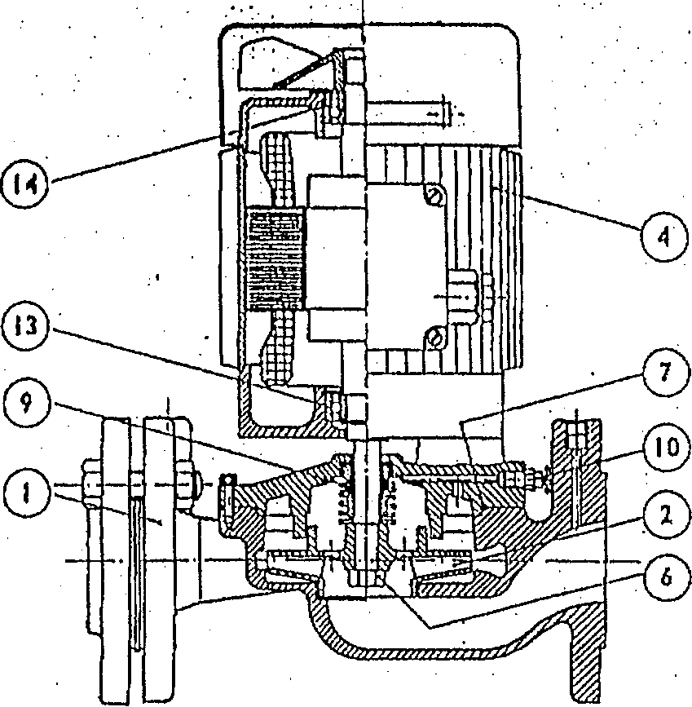

Re • SPeeifttA-niaii : 3Q0632.U-6 \q\ .

2 O d Cj -

**|8g**

h^I

**iig**

Bag

d W *

3§p

|ll|

sail

gsSS

d H S Q

= 1^3

5S m 3 3 0cgr

§"11

c?5

**|a!**

**h # j**

5sw

Kzo g a

b4

Item No. Spare Part

. I 2

6

7

9

10

13

14

. Pump casing- c. i.

Impeller"" e>«»Hze.

. Motor.-b.2SKw - tSooem,'

Impeller ■no b ••

Casing "0" ring **\*-epdm ,**

Mechanical seal - T2-<3£3ct/tf/tG> Air vent screw 1

Bearing - inboard - <b2o3“2es/ce

Bearing - outboard-<*>203-2«s/ce

DUTY

RANGE SIZE

MOTOR

YOLTAQB

F.LO

3.0.

REMARKS

row

HEAD

SUCTION

4 o

OF DENMARK

DISCHARGE

40

KW

0*2 5

VAfc\oO£

**T4- 83 6-'4T**

AMPS

AMPS

T-RANGE IN-UNE **glanded PUMPS**

;SA

782

CHAPTER 4

DRAWINGS

AE3895F Assembly L2707B Circuit Diagram

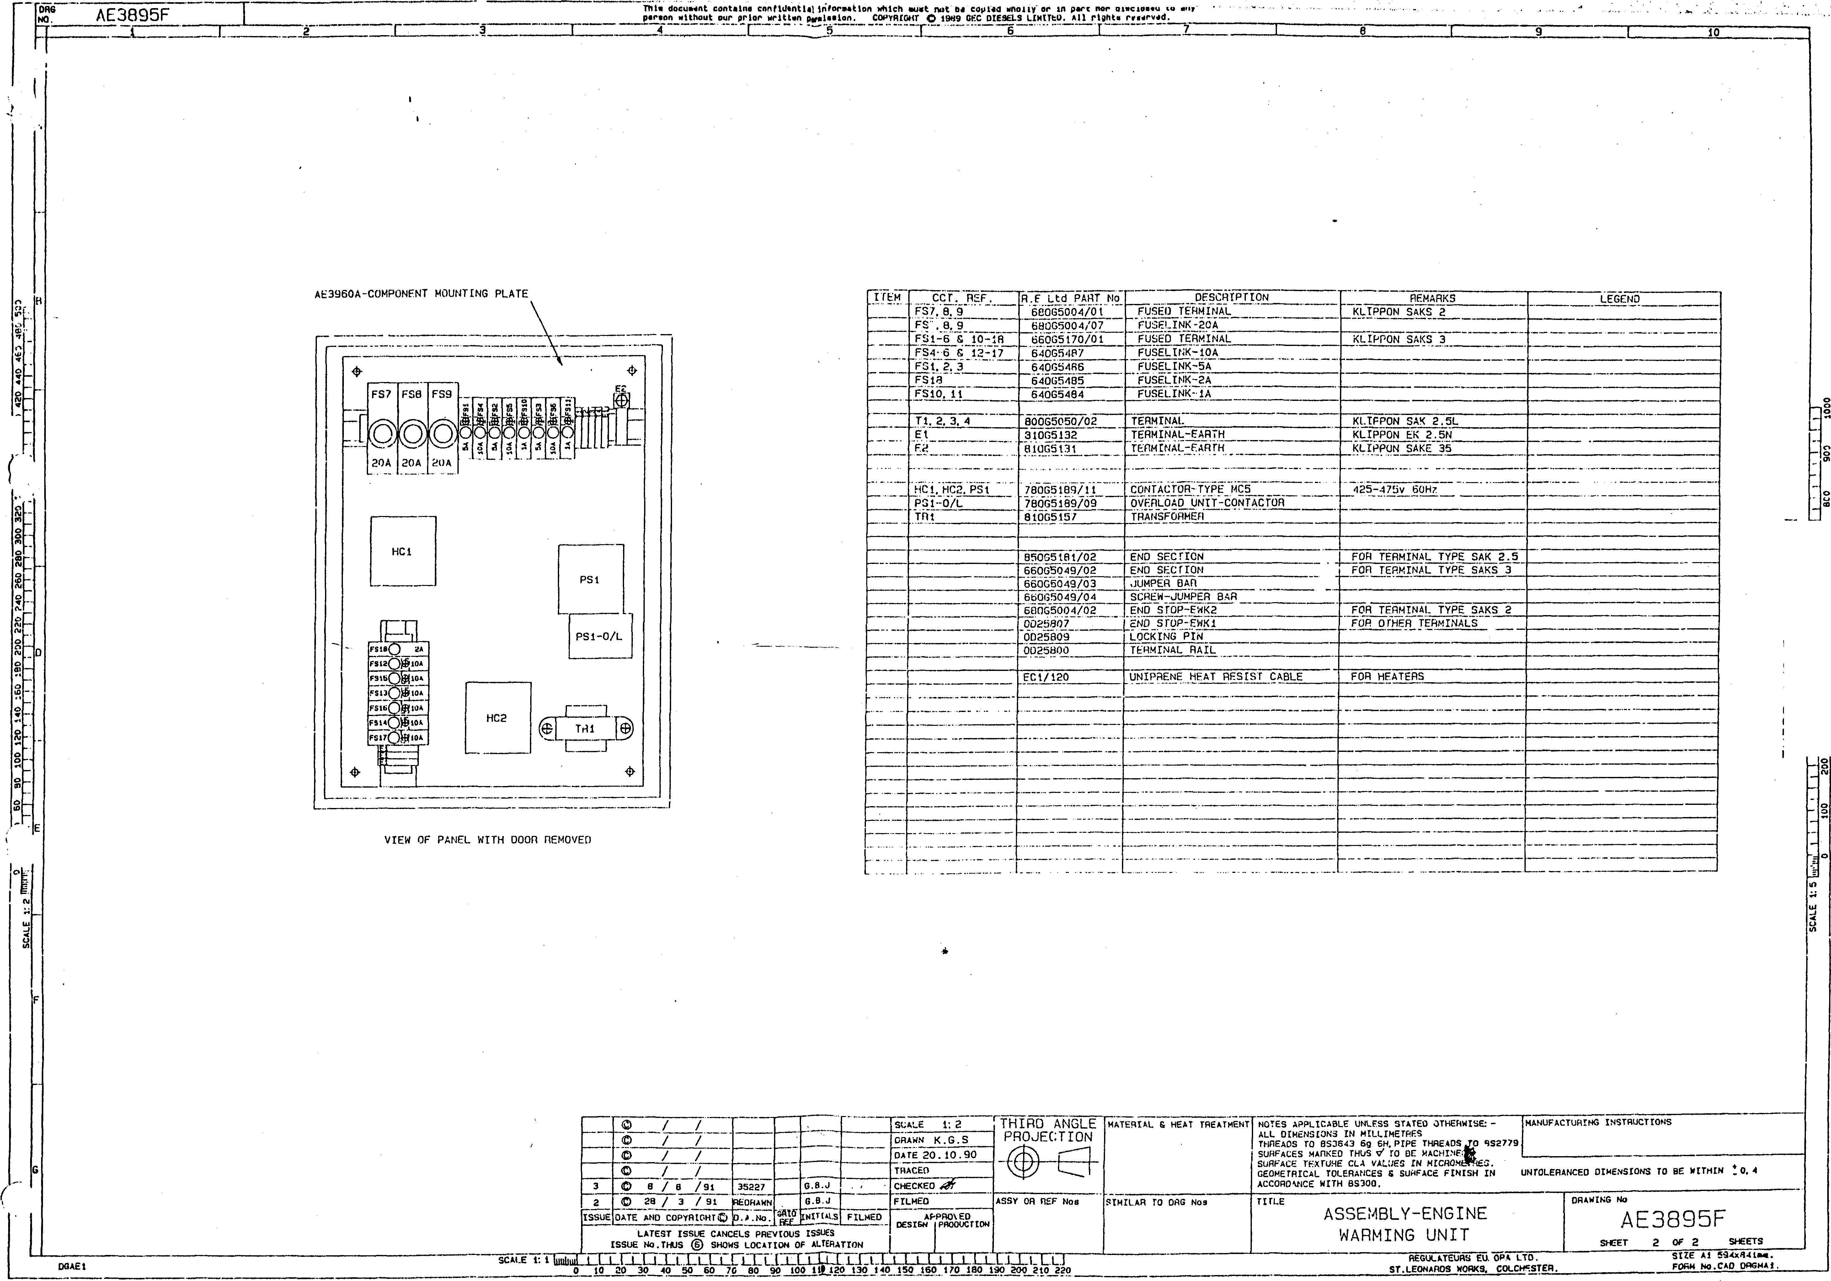

’■380 400

THIRD ANGLE PROJECTION

Thla docu««nt contain* conf td»ntl*Hnfor«ntto<i which au«t not 6< cop lid wholly In p*rt nor dtacloaad to any . ’

**fOBG\***

lN?_

AE3895F

, par ion without our prior wrlttm ptHUaion. COPYHMrtT © 1<W9 BEC DIESELS LIMITED. *11 right* roo«rv»d.

1I aI ~3~~ I 4 X 5 1 6 " ~T.7 _ | 9 I 9 " I l6

image221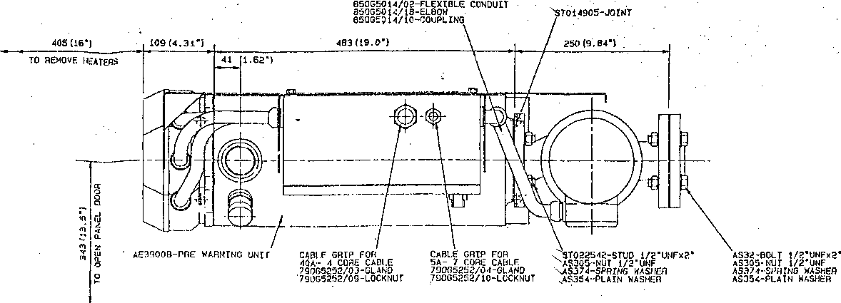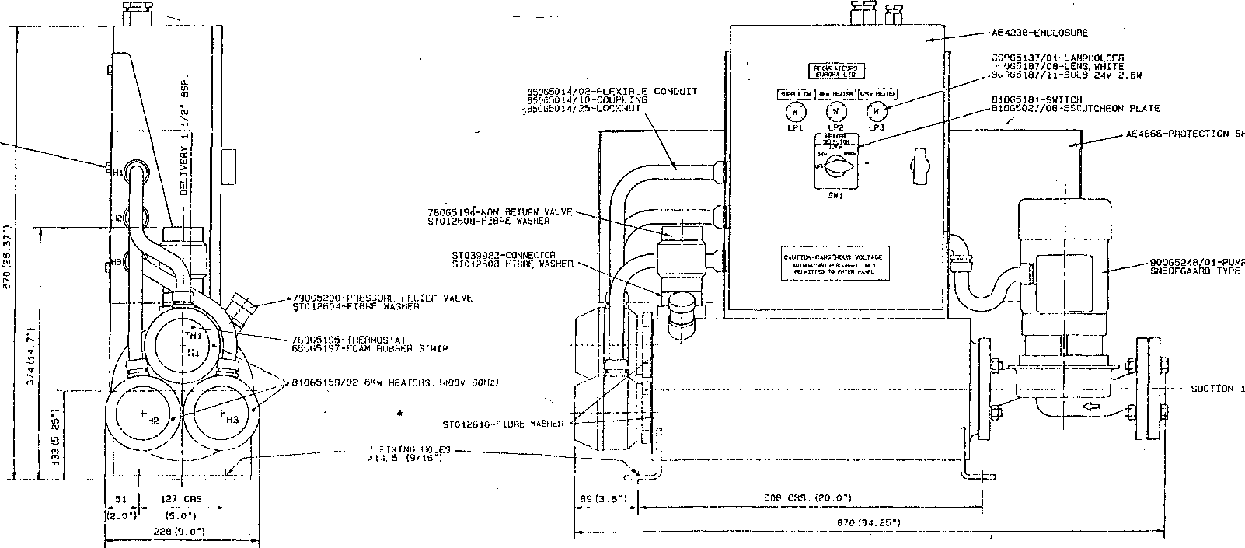

!b

I

OSaEI

AS 156-SFTSCHEW M8xl6 AS252-NUT M8 AS258-PLAIN WASHFfl M8 AS264-SPPING WASHER MB

ESrrMATED WEIGHT: -DRY WET

119Lb3. (54Kg) 149LD3. (67Kg)

O 28 / 3 / 91 IfcOHAWN

PATE AND COPYRIGHT® jp.

**”Plt|>LS**

LATEST ISSUE CANCELS PREVIOUS ISSUES  
ISSUE No . THUS (6) CHOWS LOCATION Of ALTERATION

THIRD ANGLE PROJECTION

PRAWN K . r.. s

DATE 20-10-90

THIRD ANGLE

PROJECTION

**-e-**

ASSY OR PER Noa POL SPEC. 900A91 P01

SIMILAR TO DRG Nos

NOTES APPLICABLE UNLESS STATED OTHERWISE: - ALL DIMENSIONS IN MILLIMETRESS INCHES.

THREADS TO BS3643 6g 6H.PIPE THREaOS TO 8SW779 SURFACES MARKED THUS </ TO BE MACHINEO.

SURFACE TEXTURE CLA VALUES IN MICROMETRES. GEOMETRICAL TOLERANCES S SURFACE FINISH IN ACCORDANCE WITH 8S30S.

MANUFACTURING INSTRUCTIONS

UNTOLERANCEO DIMENSIONS TO BE WtTHIM I 0. 4

TITLE

ASSEMBLY-ENGINE  
WARMING UNIT.

DRAWING No

AE3895F

SHEET 1 OF 2 SHEETS

LjL.nrx ixr [xx. l.t.1 .nxcr cell iXLi.ixixn_L.Q. lq j_i .lux

j 10 20 30 40_ 50 60 70 80 00 100 frO 120 130 140 150 160 170 ISO 190 2«» J 210 220

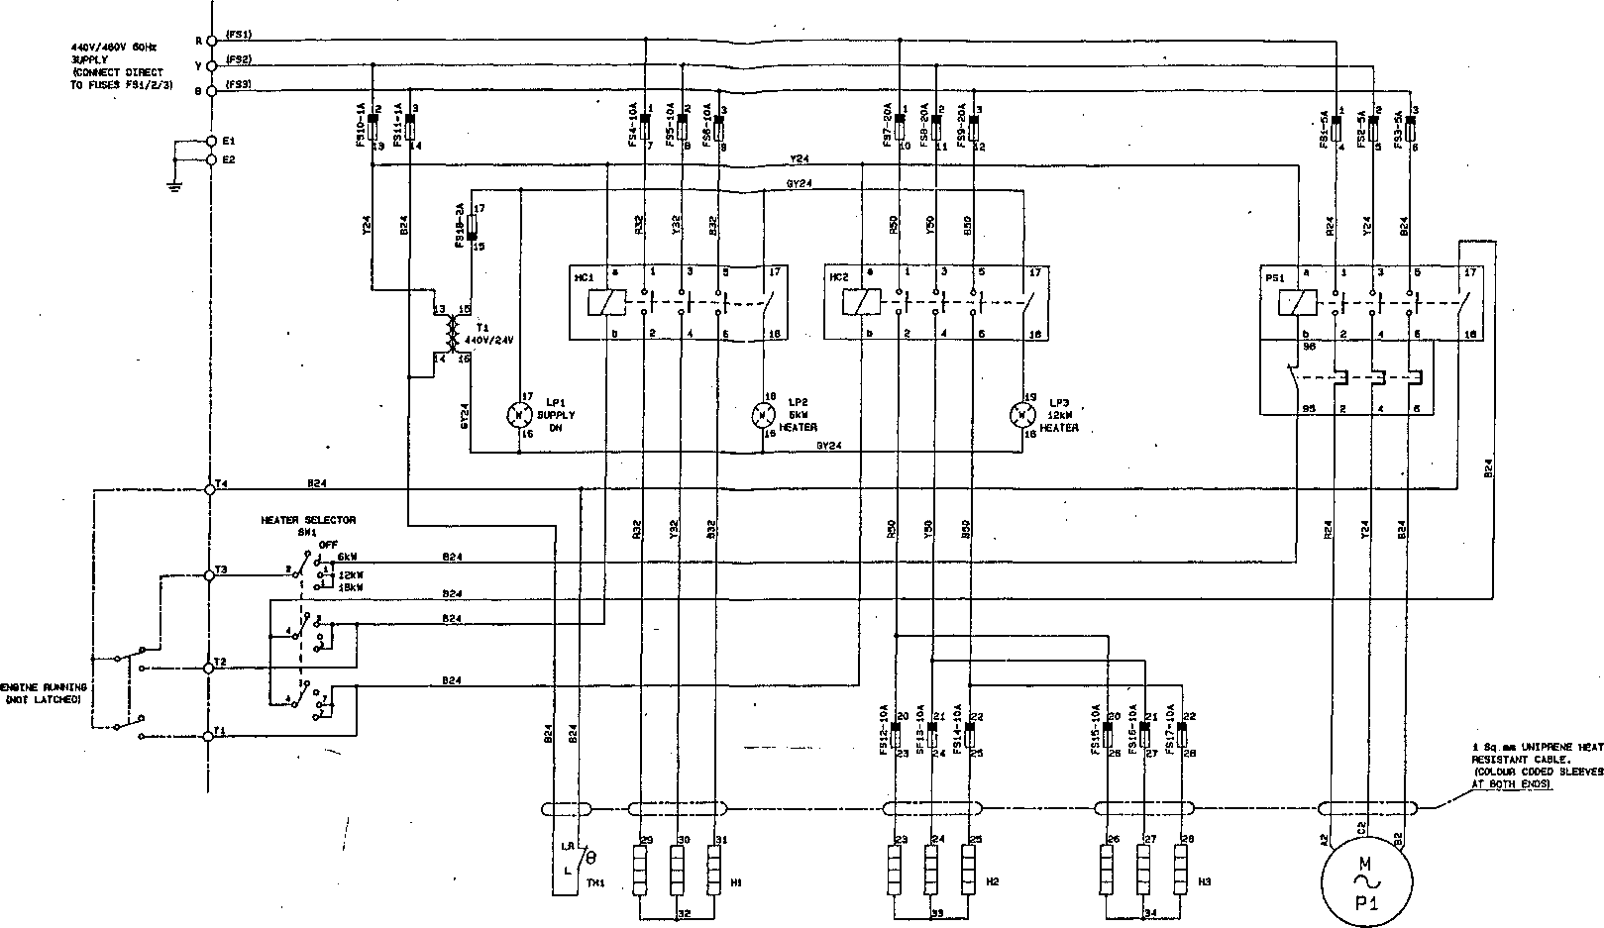

|  |  |  |  |
| --- | --- | --- | --- |
|  | © / / |  |  |
|  | © / / |  |  |
|  | © / / |  |  |
| 2 | © 12/ 4/91 | RE-ORAMN. (NO CHANGE] | 7/0&I |
| 1 | © 20/10/90 | ORIGINAL |  |
| ISSUE | DATE AND COPYRIGHT© | ALTERATION | FILMED |
| ORANN K.S.S | | CONTRACT: - . | |
| CHECKED | |

CIRCUIT DIAGRAM ENGINE WARMING UNIT

L2707B

8HEET 1 OF 1 SHEETS v ■ 1>

paraon without our prior wrlttan paralaalon. COPYRIGHT C 1»W SEC PIESEL8 LIHITH). MI rlghta rtatrvatf.